In

[9]:

In

[23]:

Assignment no. 04

Aim-

1

. Linear Regression : Univariate and Multivariate

2

. Least Square Method for Linear Regression

3

. Measuring Performance of Linear Regression

4

. Example of Linear Regression

5

. Training data set and Testing data set

**import**

pandas

**as**

pd

**import**

numpy

**as**

np

**import**

matplotlib

.

pyplot

**as**

plt

x

**=**

np

.

array

([

95

,

85

,

85

,

70

,

60

])

y

**=**

np

.

array

([

85

,

90

,

70

,

64

,

70

])

model

**=**

np

.

polyfit

(

x

,

y

,

1

)

model

Out[23]: array([ 0.53766234, 33.32467532])

In

[24]:

predict

**=**

np

.

poly1d

(

model

)

predict

(

65

)

Out[24]: 68.27272727272727

In

[25]:

y_pred

**=**

predict

(

x

)

y_pred

Out[25]: array([84.4025974 , 79.02597403, 79.02597403, 70.96103896, 65.58441558])

In

[26]:

**from**

sklearn

.

metrics

**import**

r2_score

r2_score

(

y

,

y_pred

)

Out[26]: 0.4516887333445776

[27]:

y_line

**=**

model

[

1

]

**+**

model

[

0

]

**\***

x

plt

.

plot

(

x

,

y_line

,

c

**=**

'r'

)

plt

.

scatter

(

x

,

y_pred

)

plt

.

scatter

(

x

,

y

,

c

**=**

'r'

)

Out[27]: <matplotlib.collections.PathCollection at 0x1e75c510c90>

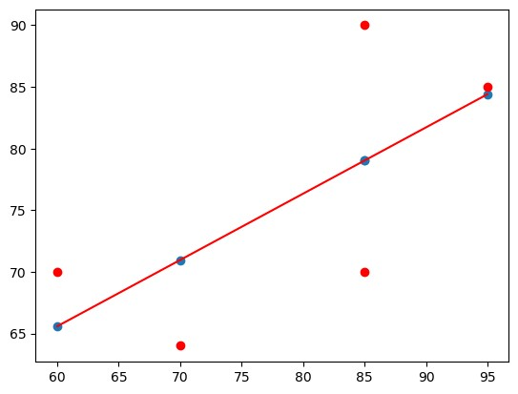

[28]: **import** ssl **from** sklearn.datasets **import** fetch_california_housing ssl._create_default_https_context **=** ssl._create_unverified_context california **=** fetch_california_housing(download_if_missing**=True**) X **=** california.data y **=** california.target california

Out[28]: {'data': array([[ 8.3252 , 41. , 6.98412698, ..., 2.55

555556,

37.88 , -122.23 ],

[ 8.3014 , 21. , 6.23813708, ..., 2.10984183, 37.86 , -122.22 ],

[ 7.2574 , 52. , 8.28813559, ..., 2.80225989,

37.85 , -122.24 ],

...,

[ 1.7 , 17. , 5.20554273, ..., 2.3256351 , 39.43 , -121.22 ],

[ 1.8672 , 18. , 5.32951289, ..., 2.12320917, 39.43 , -121.32 ],

[ 2.3886 , 16. , 5.25471698, ..., 2.61698113,

39.37 , -121.24 ]]),

'target': array([4.526, 3.585, 3.521, ..., 0.923, 0.847, 0.894]),

'frame': None,

'target_names': ['MedHouseVal'],

'feature_names': ['MedInc',

'HouseAge',

'AveRooms',

'AveBedrms',

'Population',

'AveOccup',

'Latitude',

'Longitude'],

'DESCR': '.. _california_housing_dataset:\n\nCalifornia Housing dataset\n --------------------------\n\n**Data Set Characteristics:**\n\n :Number of Instances: 20640\n\n :Number of Attributes: 8 numeric, predictive at tributes and the target\n\n :Attribute Information:\n - MedInc median income in block group\n - HouseAge median house age in block group\n - AveRooms average number of rooms per household \n - AveBedrms average number of bedrooms per household\n - Population block group population\n - AveOccup average nu mber of household members\n - Latitude block group latitude\n - Longitude block group longitude\n\n :Missing Attribute Values: No ne\n\nThis dataset was obtained from the StatLib repository.\nhttps://www. dcc.fc.up.pt/~ltorgo/Regression/cal_housing.html\n\nThe target variable is the median house value for California districts,\nexpressed in hundreds of thousands of dollars ($100,000).\n\nThis dataset was derived from the 1990 U.S. census, using one row per census\nblock group. A block group is the s mallest geographical unit for which the U.S.\nCensus Bureau publishes samp le data (a block group typically has a population\nof 600 to 3,000 peopl

e).\n\nA household is a group of people residing within a home. Since the average\nnumber of rooms and bedrooms in this dataset are provided per hou sehold, these\ncolumns may take surprisingly large values for block groups with few households\nand many empty houses, such as vacation resorts.\n\nI t can be downloaded/loaded using the\n:func:`sklearn.datasets.fetch_califo rnia_housing` function.\n\n.. topic:: References\n\n - Pace, R. Kelley and Ronald Barry, Sparse Spatial Autoregressions,\n Statistics and Pr obability Letters, 33 (1997) 291-297\n'}

[29]:

data

**=**

pd

.

DataFrame

(

california

.

data

)

data

.

columns

**=**

california

.

feature_names

data

.

head

()

Out[29]:

**MedInc HouseAge AveRooms AveBedrms Population AveOccup Latitude Longitude**

1. 8.3252 41.0 6.984127 1.023810 322.0 2.555556 37.88 -122.23
2. 8.3014 21.0 6.238137 0.971880 2401.0 2.109842 37.86 -122.22
3. 7.2574 52.0 8.288136 1.073446 496.0 2.802260 37.85 -122.24
4. 5.6431 52.0 5.817352 1.073059 558.0 2.547945 37.85 -122.25
5. 3.8462 52.0 6.281853 1.081081 565.0 2.181467 37.85 -122.25

In

[30]:

data

[

'PRICE'

]

**=**

california

.

target

data

.

isnull

().

sum

()

|  |  |
| --- | --- |
| Out[30]: | MedInc 0  HouseAge 0  AveRooms 0  AveBedrms 0  Population 0  AveOccup 0  Latitude 0  Longitude 0 PRICE 0 dtype: int64 |

In [31]: data.isnull().sum() **from** sklearn.model_selection **import** train_test_split

xtrain, xtest, ytrain, ytest **=** train_test_split(X, y, test_size**=**0.2, random_ **import** sklearn

**from** sklearn.linear_model **import** LinearRegression lm **=** LinearRegression() model**=**lm.fit(xtrain, ytrain)

In [32]: ytrain_pred **=** lm.predict(xtrain) ytest_pred **=** lm.predict(xtest) df**=**pd.DataFrame(ytrain_pred,ytrain) df**=**pd.DataFrame(ytest_pred,ytest)

**from** sklearn.metrics **import** mean_squared_error, r2_score mse **=** mean_squared_error(ytest, ytest_pred) print(mse)

mse **=** mean_squared_error(ytrain_pred,ytrain) print(mse)

0.5289841670367244 0.5234413607125447

In

[33]:

mse

**=**

mean_squared_error

(

ytest

,

ytest_pred

)

print

(

mse

)

0.5289841670367244

[34]:

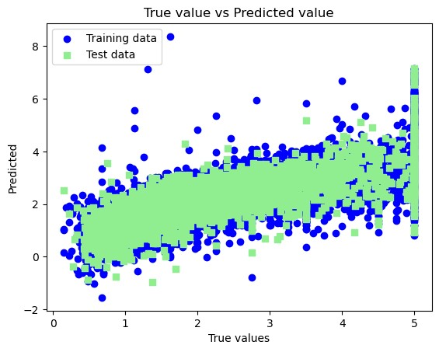

plt

.

scatter

(

ytrain

,

ytrain_pred

,

c

**=**

'blue'

,

marker

**=**

'o'

,

label

**=**

'Training data'

)

plt

.

scatter

(

ytest

,

ytest_pred

,

c

**=**

'lightgreen'

,

marker

**=**

's'

,

label

**=**

'Test data'

)

plt

.

xlabel

(

'True values'

)

plt

.

ylabel

(

'Predicted'

)

plt

.

title

(

"True value vs Predicted value"

)

plt

.

legend

(

loc

**=**

'upper left'

)

*#plt.hlines(y=0,xmin=0,xmax=50)*

plt

.

plot

()

plt

.

show

()

Name- Sharayu Nanaware Rollno:- 13243